Registration page Changes

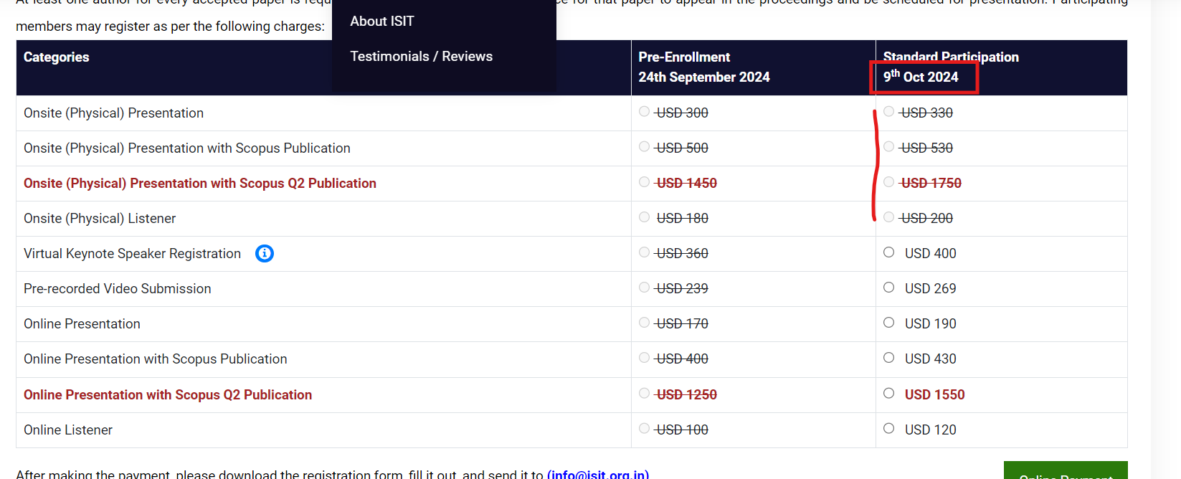

* For all the registration pages kindly remove the Date from the Standard Participation Column.
* The Strike out option should also be removed and the registration should be open for Standard Participation fee.
* .
* There are no changes in the Early Bird category column.

# 

# Strike out Option for Standard Participation Fee:

**For Sites mentioned (Set A ) Offline presentation alone should be disabled before 15 days of the conference date and others can be enabled and for (Set B ) it should be enabled for all .. Kindly check the below link for details**

**Event links for all the sites**

**CL - 2**

**SET A**

<https://researchfoundation.net/event/index.php?id=2511751>

<https://researchplus.co/event/index.php?id=2716430>

<https://worldacademics.net/event/index.php?id=2516061>

<https://scienceleagues.com/events/index.php?id=2621307>

**SET B**

<https://iiter.org/conf/index.php?id=2622074>

<https://iser.org.in/conf/index.php?id=2585416>

<https://itar.in/conf/index.php?id=2620176>

**CL - 3**

**SET A**

<https://www.iierd.org/events/index.php?id=2565294>

<https://sciencesociety.co/conf/index.php?id=2597369>

<https://researchsociety.co/event/index.php?id=2670976>

<http://sciencecite.com/event/index.php?id=2673668>

**SET B**

<https://www.iarfconference.com/conf/index.php?id=2614674>

<https://asar.net.in/event/index.php?id=2512606>

<https://after.org.in/event/index.php?id=2605861>

<https://scholarsforum.org/event/index.php?id=2760626>

**CL - 4**

**SET A**

<https://sciencenet.co/event/index.php?id=2573025>

<https://sairap.org/conf/index.php?id=2617753>

<https://isit.org.in/event/index.php?id=2602109>

<https://researchleagues.com/event/index.php?id=2571745>

**SET B**

<https://www.researchfora.net/event/index.php?id=2536345>

<https://www.wrfconference.com/event/index.php?id=2618747>

<https://isar.org.in/event/index.php?id=2537591>

<https://www.iirst.com/event/index.php?id=2577257>